CIS 1051 (Kyvernitis) Lab: “Functions”
This week, your lab will focus on writing python functions. There are two options for this program: Option 1 (no turtle) and Option 2 (turtle) – see next pages for details of the two options. Choose which option you want to do, then implement all the requirements listed under that option. The program style requirements are the same, regardless of which option you choose.

Programming Style Requirements (regardless of which option you choose):

- Program comments at the top of your program shall include:
  - Program name and detailed program functionality,
  - Programmer (you),
  - Date written
- For each function (def), comments shall:
  - List the function name and tell what the function does,
  - List all formal argument names and describe the purpose of each,
  - Describe the output value of the function.
  - Note: while it is possible for a function to have no inputs and/or provide no return value, it is not the norm.
- Your “main program” shall:
  - Provide “paragraph style” comments,
  - Use self documenting variable names (using camelCase), and
  - Use NAMED_CONSTANTS instead of “magic numbers”. You are not required to have named constants, but you are required to NOT have “magic numbers”.

Submission Requirements:

Option 1 (no turtle): attach the following two files to blackboard by the due date.
- A word (or wordpad) document named with your first and last name and “functions lab”. This document shall contain:
- a test run of your program (you can copy/paste from the python shell). In this test run, you shall make every possible mistake (e.g., not a number, too high, too low) before providing the expected input – for at least one input. Then finish off the test run, providing expected values each time.
- your python source code, copy/pasted into the document.
- Your python program named with your first and last name and “functions lab.py”.

Option 2 (turtle): attach the following two files to blackboard by the due date.
- A word (or wordpad) document named with your first and last name and “functions lab”. This document shall contain:
- a test run of your program (you can copy/paste from the python shell). In this test run, you shall make every possible mistake (e.g., not a number, too high, too low) before providing the expected input – for at least one input. Then finish off the test run, providing expected values each time.
- a screen capture of the graphics screen as it is at the end of the animation (you can use alt-prtsc to copy the active window into the clipboard).
- your python source code, copy/pasted into the document.
- A zip file named with your first and last name and “functions lab”. This zip file shall contain:
- All of of the gif image files that are referenced by your program.
- Your python program named with your first and last name and “functions lab.py”.
OPTION 1 (no turtle) Requirements

- Your program shall ask the user to enter at least 2 numeric inputs and it shall perform some calculation on those numeric inputs, then print the results of the calculation.
- Then, your program shall ask the user to enter another set of (the same type of) inputs and you will perform the same calculation on those inputs, then print the results of this second calculation.
- You may use the same kind of calculation that you have used in previous labs, but this week, you shall define a function to perform the calculation. Your program shall call that function twice – once with the first set of inputs, and once with the second set of inputs.
- Your program shall print and label all the inputs as well as all the results of the calculations (that were performed by the function you defined).
- For educational purposes, your program shall not name the variables for the first set of inputs the same as you name the second set of inputs. Also, for educational purposes, your program shall not name your formal arguments (i.e., in the function definition) the same as either set of your actual arguments (when you make the two function calls). See definitions on the previous page if you do not know what these terms mean.
- Your program shall include at least one of the following functions (in addition to the function that you define for your calculations).
- getFloat:
  - inputs:
    - a string input which is the prompt (to be displayed to the user in an input statement)
    - lowest acceptable value
    - highest acceptable value
  - returns: a real number (float) which the user has typed in.
  - Inside this function, you need to do validation as we did in a previous lab, so you will be using try/except inside of a while loop. The idea of this function is that it will handle exceptions if the user enters bad data and it will keep asking the user for input (displaying the “prompt”) until the user finally provides valid input.
- getInt: just like getFloatRange, but makes the user enter an integer that is within a given range.
  - inputs:
    - a string input which is the prompt (to be displayed to the user in an input statement)
    - lowest acceptable value
    - highest acceptable value
  - returns: an integer (int) which the user has typed in.

- Whenever your program asks the user to enter a number, it shall call one of these functions (getInt or getFloat) to get the user’s input. By calling one of these methods, you’ll get nice input validation and protection against unwanted exceptions that could abort your program.
- Your program shall use the format function, where necessary, to properly display the inputs and outputs. If you need help with the format function, refer to the powerpoint called “numeric ops and formatting” in Mod 3-4 in blackboard.

On the next page you see almost all of an example of an acceptable program and an example of how it might be executed. Of course, you may not use this exact example for your homework (nor anything too similar).

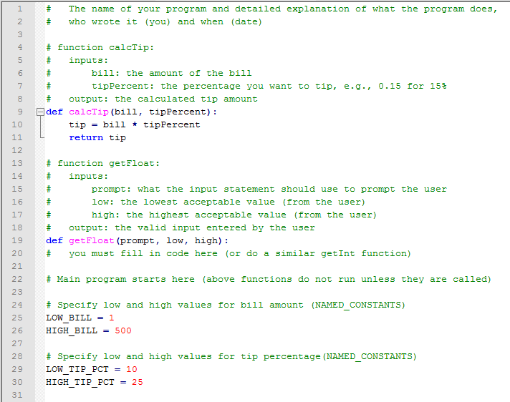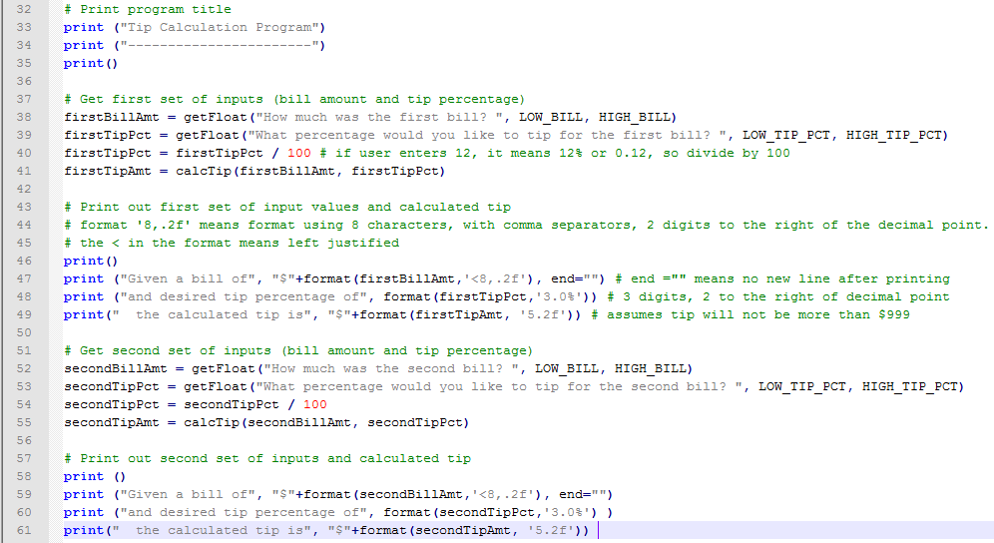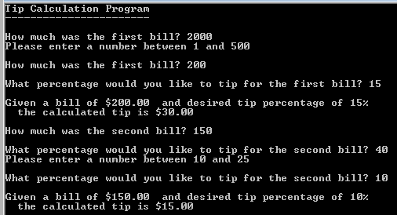
OPTION 2 (turtle) Requirements

- Your program shall ask the user to enter at least 2 numeric inputs that affect the animation.
- Then, your program shall ask the user to enter another set of (the same type of) inputs that also affect the animation.
- You may use a similar animation to what you have used in previous labs, but this week, you have to define a function to assist with the animation. Your program shall call this function twice – once with the first set of inputs, and once with the second set of inputs.
- After getting both sets of inputs, the animation shall begin.
- For educational purposes, your program shall not name the variables for the first set of inputs the same as you name the second set of inputs. Also, for educational purposes, your program shall not name your formal arguments (in the function definition) the same as either set of your actual arguments (when you make the two function calls). See the definitions on page 1 if you do not know what these terms mean.
- Your program must include one of the following functions (in addition to the function that you define for your calculations).
- getFloat:
  - inputs:
    - a string input which is the prompt (to be displayed to the user in an input statement)
    - lowest acceptable value
    - highest acceptable value
  - returns: a real number (float) which the user has typed in.
  - Inside this function, you need to do validation as we did in a previous lab, so you will be using try/except inside of a while loop. The idea of this function is that it will handle exceptions if the user enters bad data and it will keep asking the user for input (displaying the “prompt”) until the user finally provides valid input.
- getInt: just like getFloatRange, but makes the user enter an integer that is within a given range.
  - inputs:
    - a string input which is the prompt (to be displayed to the user in an input statement)
    - lowest acceptable value
    - highest acceptable value
  - returns: an integer (int) which the user has typed in.

- Whenever your program asks the user to enter a number, it shall call one of these functions (getInt or getFloat) to get the user’s input. By calling one of these methods, you’ll get nice input validation and protection against unwanted exceptions that could abort your program.
- Managing the two windows (shell and graphic): In your program, set the screen size and display the background image first, then get all of the user inputs, then do the rest of your animation. This gives you the chance (before you finish entering your inputs) to resize and move the two windows around: the shell window (where you are entering your input and possibly seeing debug values printed) and the graphics window (where your animation takes place).
Additional Help: how you define and call a function

Here is an example of how you define a function (lines 4-6) and how you call a function (line 11 and line 13):

- # function myAdd:
- # inputs: two numbers
- # output: the sum of those two numbers
- def myAdd(num1, num2):
- sum=num1+num2
- return sum

- # Main program (starts here after all the functions)
- i=4
- j=5
- z=myAdd (i,j)
- z= print ("the sum of", i, "and", j, "is", z )
- print ("The sum of 3 and 10 is", myAdd (3,10) )

- Recall that functions are not executed unless they are called, so the first line of code executed is always after any/all function definitions.

- The input arguments in a function definition (e.g., num1 and num2 in line 4) are called Formal Arguments. The function performs its calculations on these input arguments knowing that whoever will call the function will provide the values when they make the call.

- To call (or invoke) a function, you provide the name of the function and as many arguments as the function expects. In the sample code below, line 11 makes a call to function myAdd passing in two arguments: i and j. The input arguments in a function call are called Actual Arguments. Actual arguments must always be initialized with some value before the call is made. Another call to function myAdd is made in line 13. In this line, the actual arguments are integer constants 3 and 10. Note: it probably is not good programming style to call a function with numeric constants (at least you should provide NAMED_CONSTANTS instead of “magic numbers”).

